EARTHQUAKE PREDICTION MODEL USING PYTHON



PHASE 1: PROBLEM DEFINITION AND DESIGN THINKING

An earthquake prediction must specify the expected magnitude range, the

geographical area within which it will occur, and the time interval within

which it will happen with sufficient precision so that the ultimate success

or failure of the prediction can be readily judged.

- Objective: Develop a predictive model for earthquake magnitudes.

- Data Source: Utilize a Kaggle dataset containing earthquake-related

information, including date, time, latitude, longitude, depth, and

magnitude.

- Tasks:

1. Explore and understand the dataset's structure and contents.

2. Visualize the data on a world map for a global overview.

3. Split the dataset into training and testing subsets for model validation.

4. Develop a neural network model for earthquake magnitude

prediction.

5. Train the model on the training data and evaluate its performance on

the test data.

Design Thinking

Data Source Selection:

We will begin by selecting a suitable Kaggle dataset that contains

earthquake data with the necessary features, including date, time,

latitude, longitude, depth, and magnitude. The dataset should be

comprehensive and up to date for accurate predictions.

Feature Exploration:

Upon acquiring the dataset, we will thoroughly analyse and explore its

features. This exploration will include understanding the distribution,

correlations, and characteristics of key features. This step is crucial for

feature engineering and model development.

Visualization:

To gain a global overview of earthquake frequency and distribution, we

will create a world map visualization using latitude and longitude data.

This visualization will provide valuable insights into the geographic

patterns of earthquakes and can aid in feature selection. 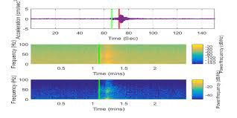

Data Splitting:

To ensure the model's reliability, we will split the dataset into two subsets:

a training set and a test set. Typically, an 80/20 or 70/30 split will be

considered, with the larger portion allocated to training. This will allow us

to train the model on one subset and evaluate its performance on an

independent subset.

Model Development:

We will design and build a neural network model tailored for earthquake

magnitude prediction. The architecture of the neural network, including

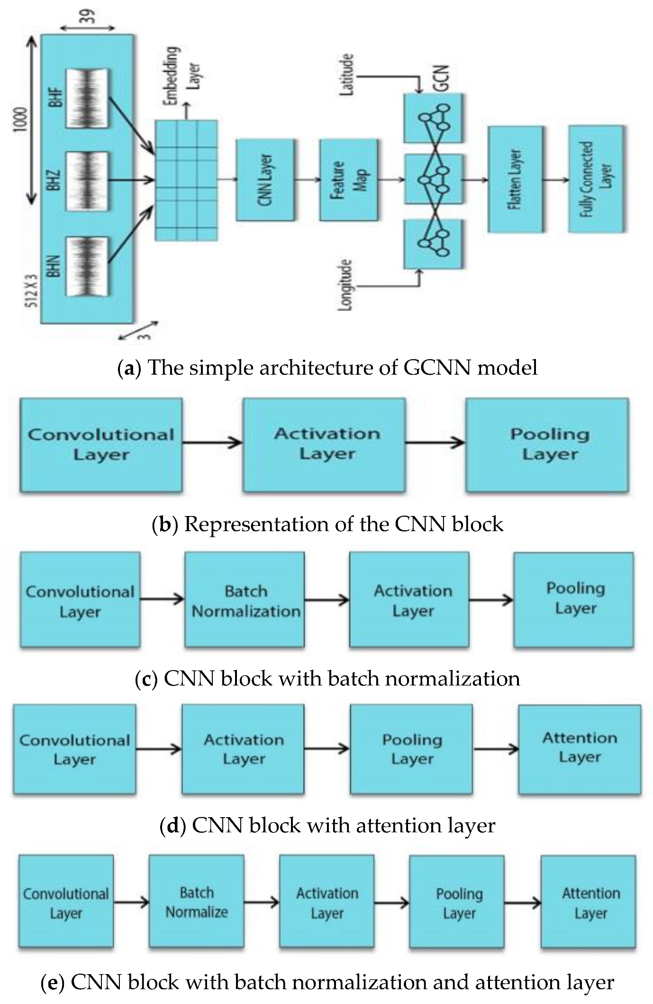 the number of layers and neurons, will be determined based on

experimentation and optimization.

SVM:

- In another terms, Support Vector Machine (SVM) is a classification

and regression prediction tool that uses machine learning theory to

maximize predictive accuracy while automatically avoiding over-fit to

the data.

NN:

ss

largest seismic event in the following month based on the analysis of eight

mathematically computed parameters known as seismicity indicators.

Training and Evaluation:

The model will be trained on the training dataset using suitable

optimization algorithms. We will monitor the model's training progress

and evaluate its performance using regression metrics such as Mean

Absolute Error (MAE), Mean Squared Error (MSE), and R-squared.

Hyperparameter tuning may be performed to enhance performance.

Conclusion

This design document outlines the initial phase of our project to develop

an earthquake prediction model. It defines the problem statement,

highlights key tasks, and outlines the design thinking approach. The next

steps involve dataset acquisition, feature exploration, visualization, and

model development. Subsequent phases will focus on model refinement,

validation, and reporting of results. An earthquake prediction must specify

the expected magnitude range, the geographical area within which it will

occur, and the time interval within which it will happen with sufficient

precision so that the ultimate success or failure of the prediction can be

readily judged